**Club Coaches**

Dave Graham, Sylvia Graham, Cherith Graham & Mark Davies

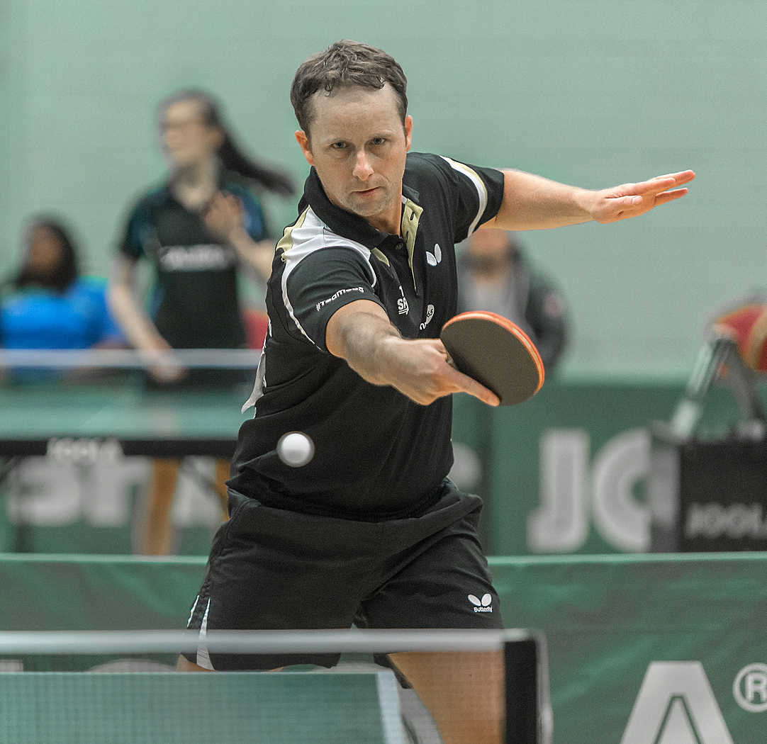

**Ryan Jenkins**

UKCC Level 4 Coach

National Coaching Manager - TTW

12 x Men’s National Champion

6 x Commonwealth Medallist

Pro-Player in Sweden, Germany, Switzerland, Denmark & Belgium

**Dates:**

**Monday 21st**

**Tuesday 22nd**

**Wednesday 23rd**

**August**

**Summer Camp**

**Crosby Table Tennis**

**Coaches:**

**Training Camp Details: (open to all ages and abilities)**

**Times: 9:00am – 12:00pm (Group A), 1:30-4:30pm (Group B)**

**Cost: 3 Days - £90.00 each (£10 per player, per hour) You can’t be in both groups !**

**Venue: Crosby High School, 15 De Villiers Ave, Liverpool L23 2TH**

Payment Form:

Places will be allocated on a “first come first serve’ basis. To reserve your place on the camp, please complete the form and send it to sylvia@graham137.freeserve.co.uk Your place will be provisionally confirmed upon receipt of this form.

Payment is required by Monday 7th August 2017.

3 Days = £90.00

Payment Details:

BACS payment Account Name: Formby Table Tennis Centre

Account No:80492515

Sort Code: 20/80/33

Please reference player name when paying via BACS. For any other payment methods, please get in contact.

Accommodation is also available at an extra cost if needed - please contact Dave & Sylvia for details.

Camp Highlights:

* Footwork Drills
* Service and Return Exercises
* Multiball
* Improving Technique
* Service Seminar
* Table Tennis Specific Fitness
* Match Play and Tactics

**Player Details**

Participants Name: _________________________________________

Date of Birth: _____________ Mobile Number: _____________

Address: _________________________________________________

Email Address: ____________________________________________

Playing Level: __________________(ranking if applicable) ________

Any Medical Information: ___________________________________

Emergency Contact Name/Number: _______________________

Group Preference (A or B): ___________

I accept full responsibility for my/my child’s participation. I relieve the coaches, sponsors and any others involved in the class of any responsibility for any injury, loss or damages.

I give my consent to the publication of photographs and/or film recording by or on behalf of the camp organisers (for myself or my child’s/children’s taking part in the above training camp)

Signature (type name if submitting electronically): ___________________________

Date: ____________________ (parent’s signature for those under 18)

If you are submitting this form electronically then you should note that in the absence of this signature the emailing of this application constitutes your personal certification that the details are correct.

Crosby Table Tennis Summer Camp

Brought to you by Crosby Table Tennis Club

@ Crosby High School,15 De Villiers Ave, Liverpool L23 2TH

21/22/23 August, 9.00am – 4.30pm (Free carpark is available)